At-Home Learning Options
June 1-5
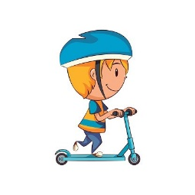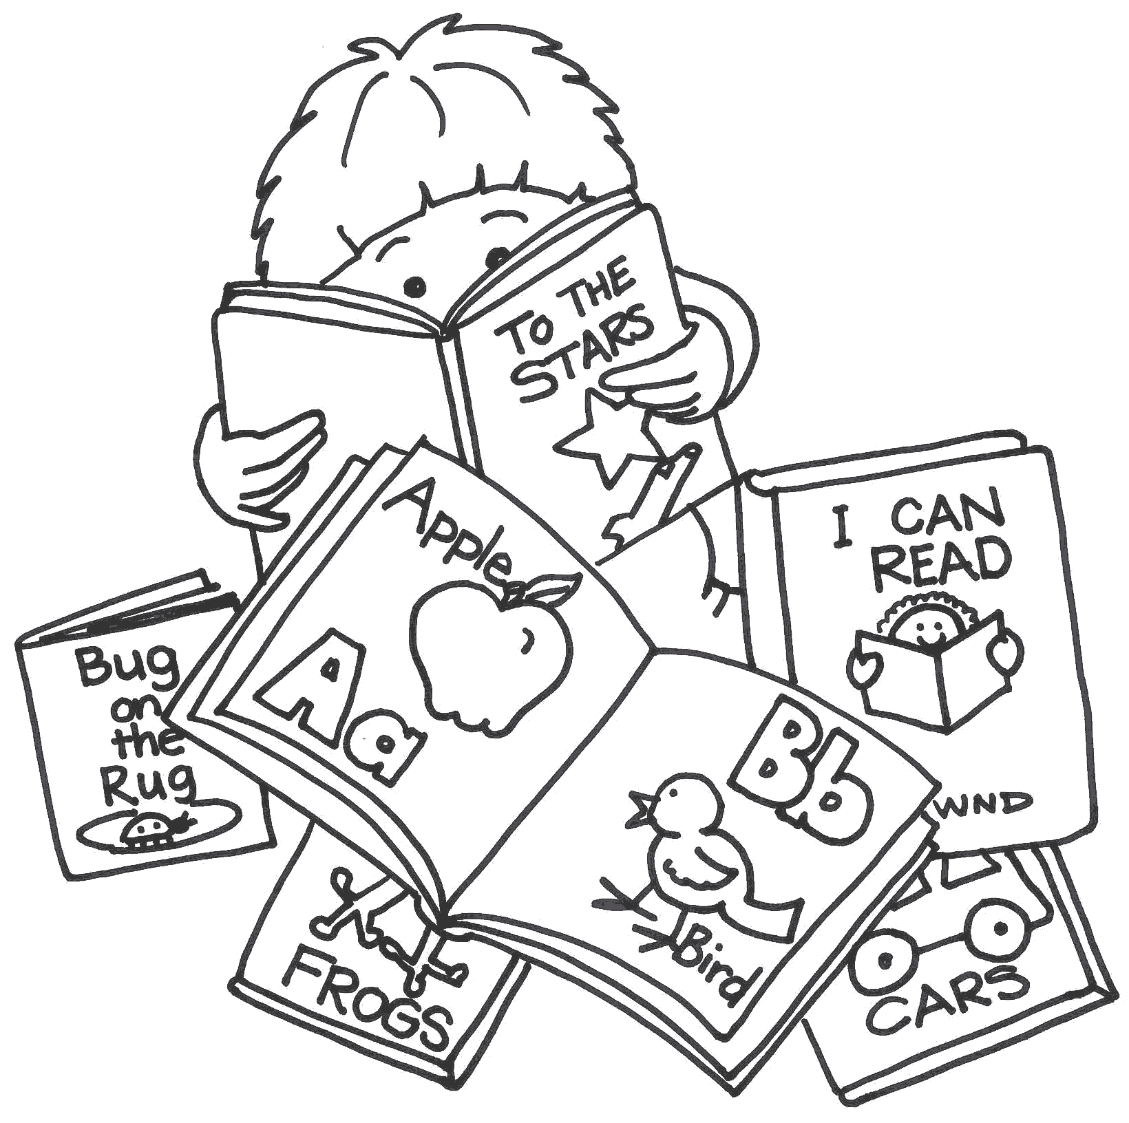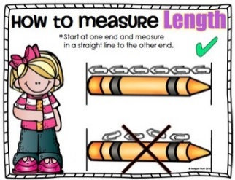
https://k2020.weebly.com/ Check here to find direct links to videos, games, etc.
Monday | Tuesday | Wednesday | Thursday | Friday
Raz-Kids:  Listen, Read & complete questions for 2 books. Be sure to use your strategies: Eagle Eye, Lips the Fish & Stretchy Snake. | Raz-Kids:  Listen, Read & complete questions for 2 books.  Use your reading strategies. | Raz-Kids:  Listen, Read & complete questions for 2 books  Use your reading strategies. | Raz-Kids:  Listen, Read & complete questions for 2 books  Use your reading strategies. | Raz-Kids:  Listen, Read & complete questions for 2 books  Use your reading strategies.
Sight Words  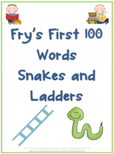  There are six Snakes and Ladders games to choose from. Once one game becomes too easy move on to the next game. | Sight Words  Let’s spell  Using a device of choice tablet, computer, etc, type each of your sight words two or three times. If you unable to use a device just write your words on paper using markers, pen or pencils. | Sight Words  Pick five sight words and use them to write a sentence or two. Underline all the sight words that you used in your sentences. | Sight Words  Speed Read  Set the timer on the stove or on your phone for one minute. Read as many sight words as you can. Count how many words you got right. Review the words you missed. Repeat the activity again. Did you know a few more sight words this time? | Sight Words  Draw a road on a large piece of paper or outside with chalk. Write some sight words along the road. Have your child drive a car or walk a doll on the road and say each word as they move pass the words.  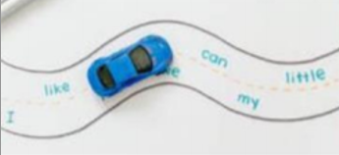
Writing:  15 - 20 minutes maximum  Write about what you want to be when you grow up. Can you tell us why?  Remember to brainstorm first, then: Think, Draw and Write. | Rhyming:  Rocco the Rhyming Rhino  Click Here  Complete rhyming sheets. Remember you don’t have to print the sheets off, you can also complete them verbally. | Writing:  15 - 20 minutes  If you could have any animal as a pet, what would it be? What would you name him or her and how would you take care of them?  Make sure to use a capital, finger spacing and periods. | Syllables  Go on a syllable hunt outside. How many things can you find with  1 syllable , 2 syllables,  3 syllables and 4 syllables.  Remember clapping  the name of the object will  help you identify how many syllables it has. | Art:  Do you have any paper towel rolls laying around? Let your imagination run wild. What kind of creature will you make?  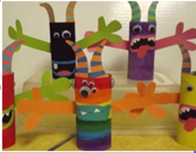
Math  Counting  On the floor or outside make a giant number line 1-12 using tape, chalk, etc. Count forward & backwards by walking or jumping along the numbers. Try starting at different numbers. Have someone ask you to step on the number that comes before 10 or after 6. Try other numbers.  Challenge  Jump to the number that is one more or two less from a given number. | Math  Dino War Addition Game  Using a deck of playing cards,  each person draws two cards  from the stack and adds the two numbers together. The person with the largest sum gets to keep all four cards. Play until the stack of the cards each player has.  Addition Video: Click Here  Please complete  addition work sheets. | Math  Non-standard Measurement  Sesame Street Measure  Video: Click Here  Choose someone at home to measure using items you find around your house. Repeat this 3 or more times with other items.  Examples:  Mom is ___ cans long.  Mom is ___ shoes long.  Challenge:  Draw a picture of the person you measured showing how many of each item you had to use. | Math  Subtraction Game  Make number cards from 0-10 out of recipe cards,  cardboard or paper. Cut them out and place in a bowl. Pull out two cards from the bowl and use them to help you write a subtraction sentences.  Example: 5-1 =4.  Make sure the bigger number is first.  Please complete subtraction work sheets. | Math  Part, Part, Whole  Simply put, “Part, Part, Whole” is just a number that is split into two smaller parts. When these parts are added together they equal the number.  Using 10 counters show different ways of breaking up 10. (EX: 4+6, 7+3, 8+2=10)  Number Bonds Video:  Click Here  Please complete work sheets.

Rocco the Rhyming Rhino
https://www.youtube.com/watch?v=nAUdQZ8Xivw

Addition
https://www.youtube.com/watch?v=UqQ1VkBvuRs

Number Bonds
https://www.youtube.com/watch?v=lD9tjBUiXs0

Sesame Street Measure
https://www.youtube.com/watch?v=2IAl5R23rco

