At-Home Learning Options
June 8-12
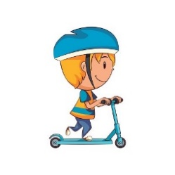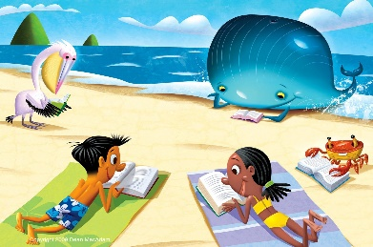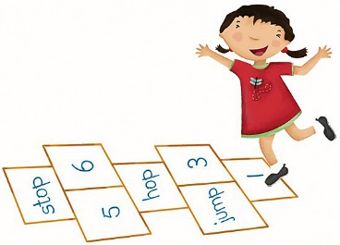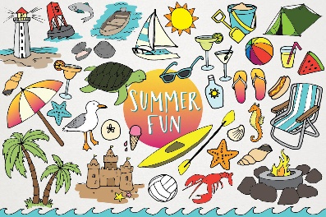
https://k2020.weebly.com/ Check here to find direct links to videos, games, etc.
Monday | Tuesday | Wednesday | Thursday | Friday
Raz-Kids:  Listen, Read & complete questions for 2 books. Be sure to use your strategies: Eagle Eye, Lips the Fish & Stretchy Snake. | Raz-Kids:  Listen, Read & complete questions for 2 books.  Use your reading strategies. | Raz-Kids:  Listen, Read & complete questions for 2 books  Use your reading strategies. | Raz-Kids:  Listen, Read & complete questions for 2 books  Use your reading strategies. | Raz-Kids:  Listen, Read & complete questions for 2 books  Use your reading strategies.
Sight Words  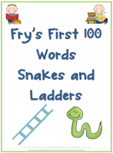  There are six Snakes and Ladders games to choose from. Once one game becomes too easy move on to the next game (see printables included with the learning options last week). | Summer Word Searches  See printables for word search pages.  Print or find and trace the summer words with your finger on the screen. | Sight Words  Make a hopscotch with your sight words. Say each word as you hop on it.  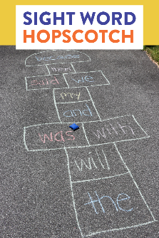 | Word Families  In your neatest printing write a list of words that rhyme with cat.  ‘at’ word family video  Click here  Can you print a list of words that rhyme with grin?  ‘in’ word family video  Click here | Sight Words  Draw a road on a large piece of paper or outside with chalk. Write some sight words along the road. Have your child drive a car or walk a doll on the road and say each word as they move pass the words.  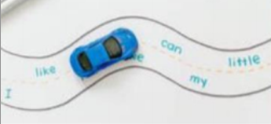
Writing:  15 - 20 minutes maximum  Opinion Writing (see printables for writing pages)  Cupcakes or Cookies?  Remember to brainstorm first: Think, Draw and Write. | Vowels:  a, e, i, o, u  Vowel Song: click here  Complete vowel sounds sheets. Remember you don’t have to print the sheets off, you can also complete them verbally. | Writing:  15 - 20 minutes  My Summer Bucket List (see printables)  Video: click here  What would you like to do this summer? Brainstorm with an adult and then print your list of ideas! | CVC Words  (Consonant, Vowel, Consonant)  CVC Video: click here  Complete practice sheets. Remember you don’t have to print the sheets off, you can also complete them verbally. | You & Your World  5 Senses:  Listen to Mrs. Hunter read:  Our Five Senses  Click here  Complete the Five Senses review page (printables)  Remember you don’t have to print the sheets off, you can also complete them verbally.
Math  Play the Jungle Race Game  (see printables)  Remember to use the counting on strategy (start with the bigger number, then count on from there).  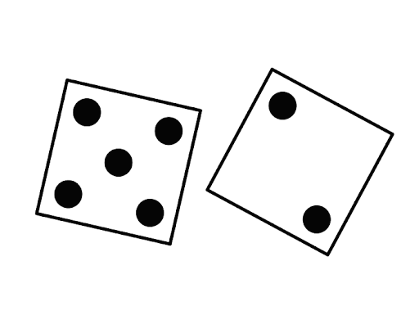 Start with 5 (the bigger number, then count on): 5…6, 7. | Math  Measurement Scavenger Hunt  (see printables)  Also, complete practice pages and/or click here for online practice. | Math  Practice printing the numbers 0 to 10 neatly on a piece of paper or outside with chalk. Can you print the numbers 11 to 20?  Remember to use your best number formation!! | Math  Draw 2 animals. How many legs do you see?  Draw a picture, use numbers and words.  Challenge: Can you write an adding sentence to match your picture?  (example: 4 + 0=4)  Complete Draw to Add Practice Page or  practice online (click here) | Math  Choose a Math Game to play:  Molly’s more or Less Quest  (click here)  Monster Mansion Match  (click here)  Molly Adds up to 10  (click here)

