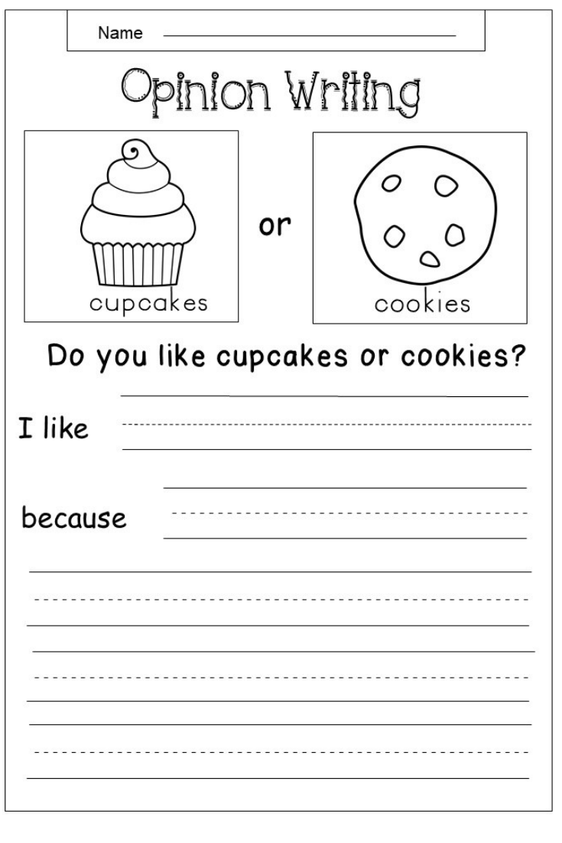

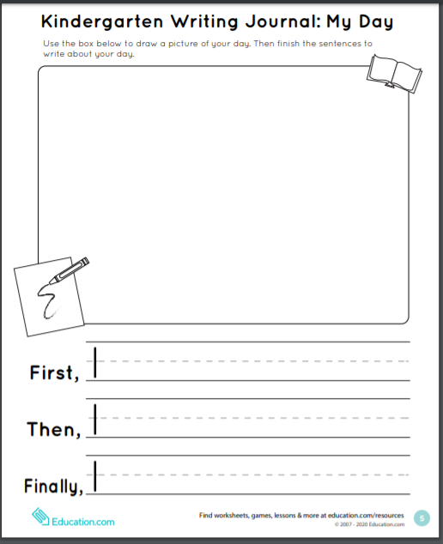

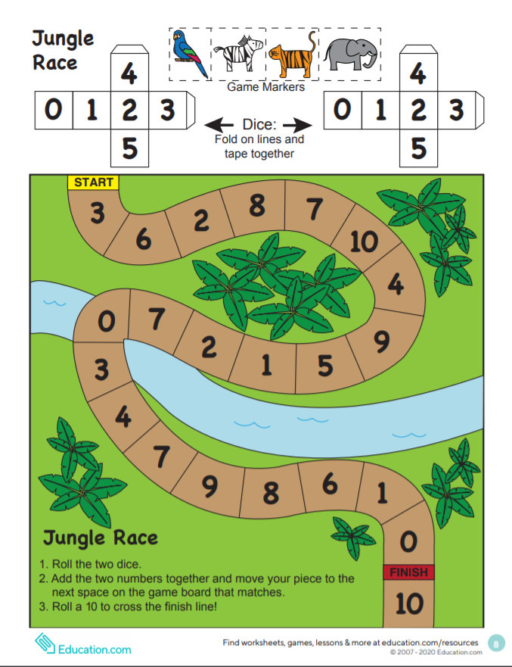

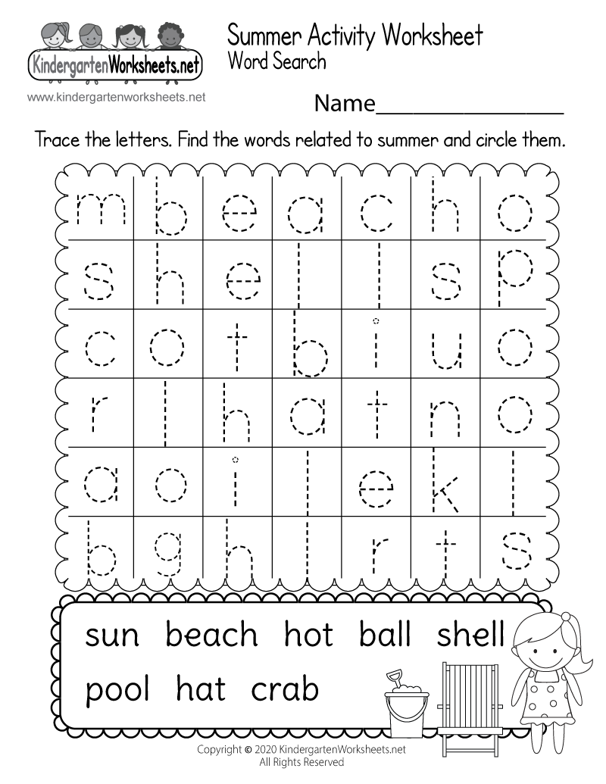

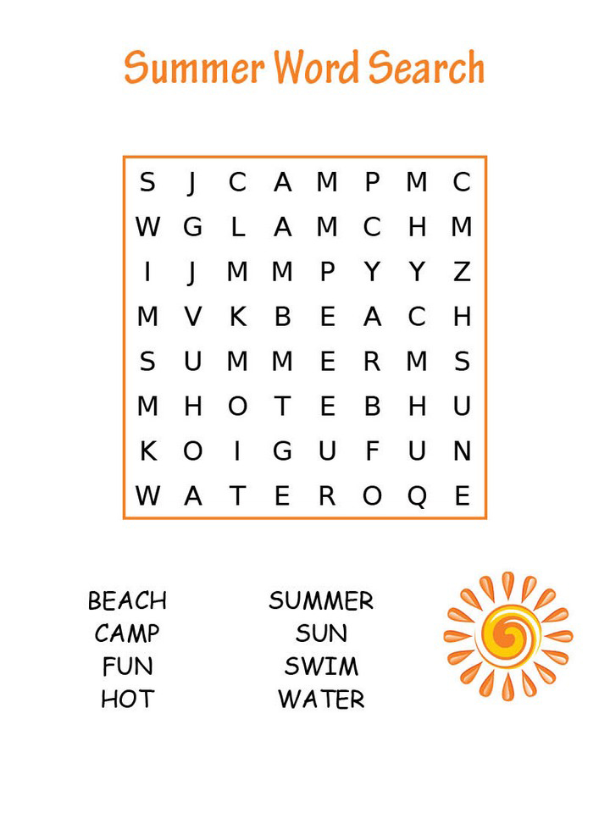

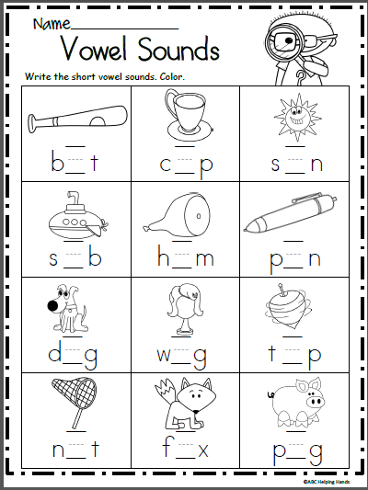

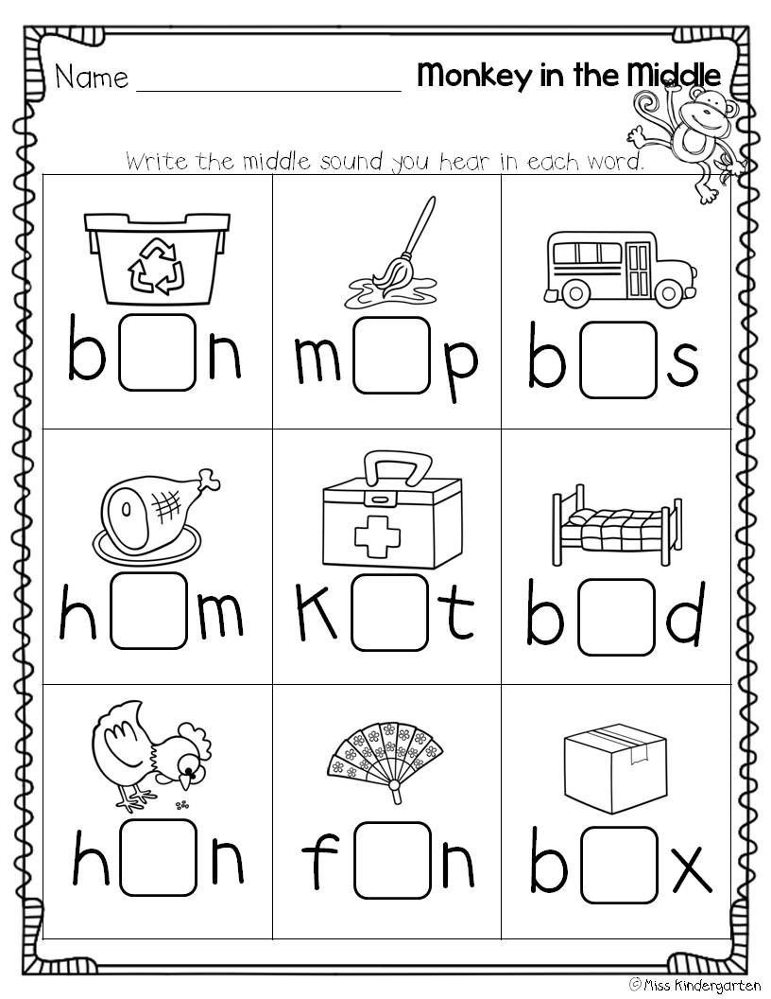

**Measurement Scavenger Hunt**

Make an X or colour each box as you find the item. HAVE FUN!

|  |  |  |
| --- | --- | --- |
| Something longer than your kitchen table | Something that is about the same length as your shoe  Converse clipart basketball shoe, Converse basketball shoe ... | Something or someone that is about the same height as you |
| Something heavier than you | Something lighter than a shoe | Something that holds less than a coffee cup |
| Something that can help to measure how long something is  Download Free png Yellow Ruler Measuring Element, Ruler Vector ... | Something that helps measure when baking | Something about the same length as your thumb |
| Something that holds more than a coffee cup | Something that is longer than a crayon  Clip Art: Crayon Green Color I abcteach.com | abcteach | Something shorter than your front door |

